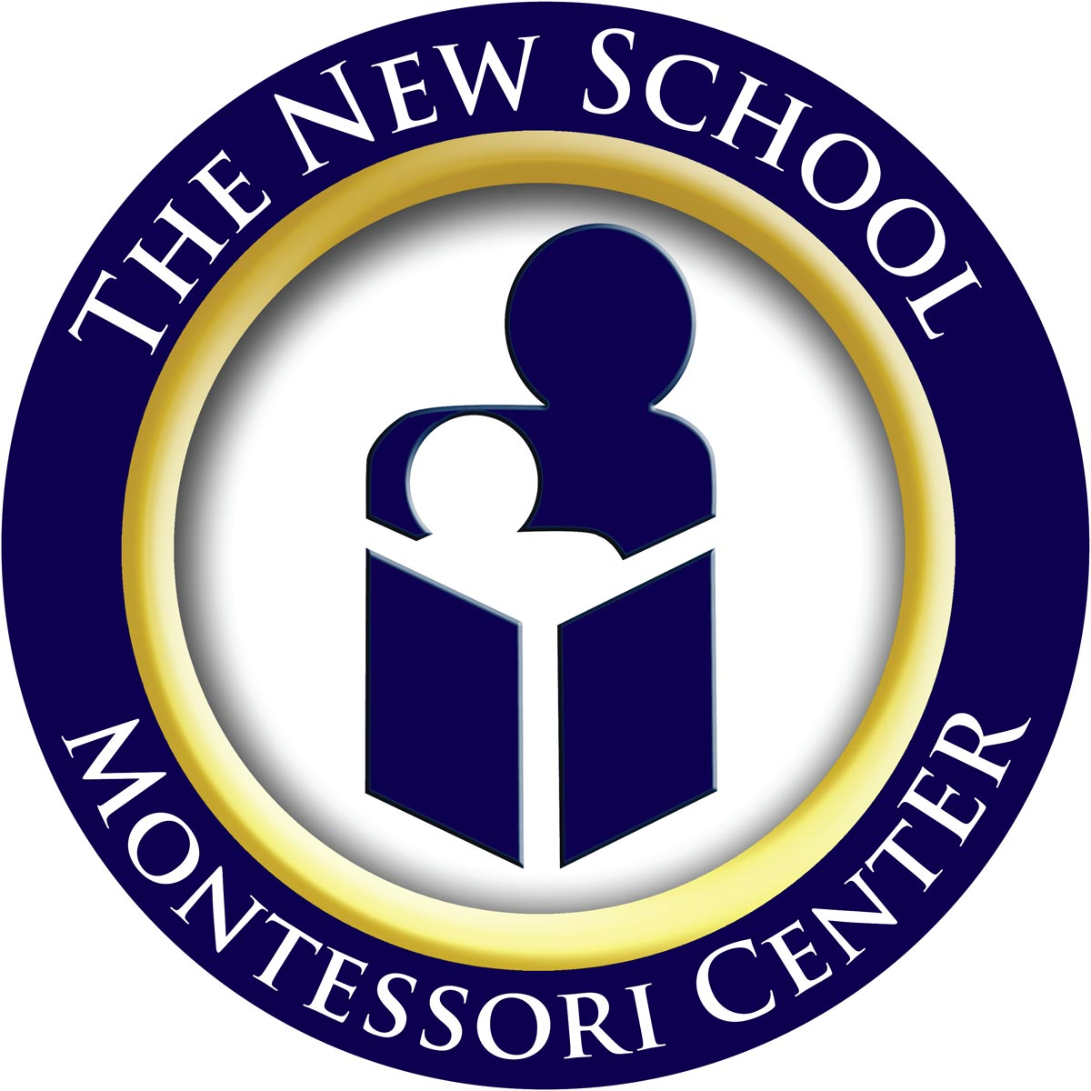
Tuition Rates for 2011/2012 School Year
Program | Hours | * Total Tuition & Fees
Half Day Toddler Ones  (12 months to 24 months) | 8:30am to 12:00pm  Mon through Fri | $6,600.00
Full Day Toddler Ones  (12 months to 24 months) | 8:30am to 4:30pm  Mon through Fri | $10,800.00
Half Day Toddler Twos  (24 months to 36 months) | 8:30am to 12:00pm  Mon through Fri | $6,300.00
Full Day Toddler Twos  (24 months to 36 months) | 8:30am to 4:30pm  Mon through Fri | $10,200.00
Half Day Children’s House  (3 years to 6 years) | 8:30am to 12:00pm  Mon through Fri | $5,500.00
Extended Day Children’s House  (3 years to 6 years) | 8:30am to 3:00pm  Mon through Fri | $7,600.00
Full Day Children’s House  (3 years to 6 years) | 8:30am to 4:30pm  Mon through Fri | $9,000.00
Lower Elementary  (6 years to 9 years) | 8:30am to 3:30pm  Mon through Fri | $8,400.00
Upper Elementary  (9 years to 12 years) | 8:30am to 3:30pm  Mon through Fri | $8,900.00
Middle School  (12 years to 15 years) | 8:30am to 3:30pm  Mon through Fri | $8,900.00

Please note that the total amounts reflected in the chart above represent payment for all regular tuition, enhancement classes, snack fees, insurance fees, and supply fees during the traditional school year (180 school days).
The fees do not cover the one-time application fee of $100.00, our summer school schedule, after-school clubs, or field trips.
For details on tuition payment plans and enrollment information, please contact the school at info@montessoricenter.org.

Before and After Class Fees for Toddlers
Program Time | Hours | Child Care Rate
Before Class Hours | 7:30am to 8:30am  Mon through Fri | $7.60 per hour
Extended Class Hours for toddlers not enrolled in a full day program | 12:00pm to 4:30pm  Mon through Fri | $9.50 per hour
After Class Hours | 4:30pm to 6:00pm  Mon through Fri | $7.60 per hour

Before and After Class Fees for Early Childhood and Elementary
Program Time | Hours | Child Care Rate
Before Class Hours | 7:30am to 8:30pm  Mon through Fri | $5.15 per hour
Extended Class Hours for  Early Childhood not enrolled in a full time program | 12:00pm to 4:30pm  Mon through Fri | $7.00 per hour
After Class Hours for Early Childhood | 4:30pm to 6:00pm  Mon through Fri | $5.15 per hour
After Class Hours for Elementary | 3:30pm to 6:00pm  Mon through Fri | $5.15 per hour

Nondiscriminatory Policy
The New School Inc. does not discriminate on the basis of race, gender, religion, or ethnic or national origin in the administration of its educational programs, admissions and hiring policies, or any other rights, privileges, or other school-related activities made available to the students and families at the school.
Tuition Assistance
The school offers need-based tuition assistance for families who qualify. To find out more about this program, please visit our website at www.montessoricenter.org.
Sibling Discount
Families with two children enrolled in the school will receive a $100 discount off each of their children’s annual tuition. Families with three children will receive a $200 discount off each of their children’s tuition.

