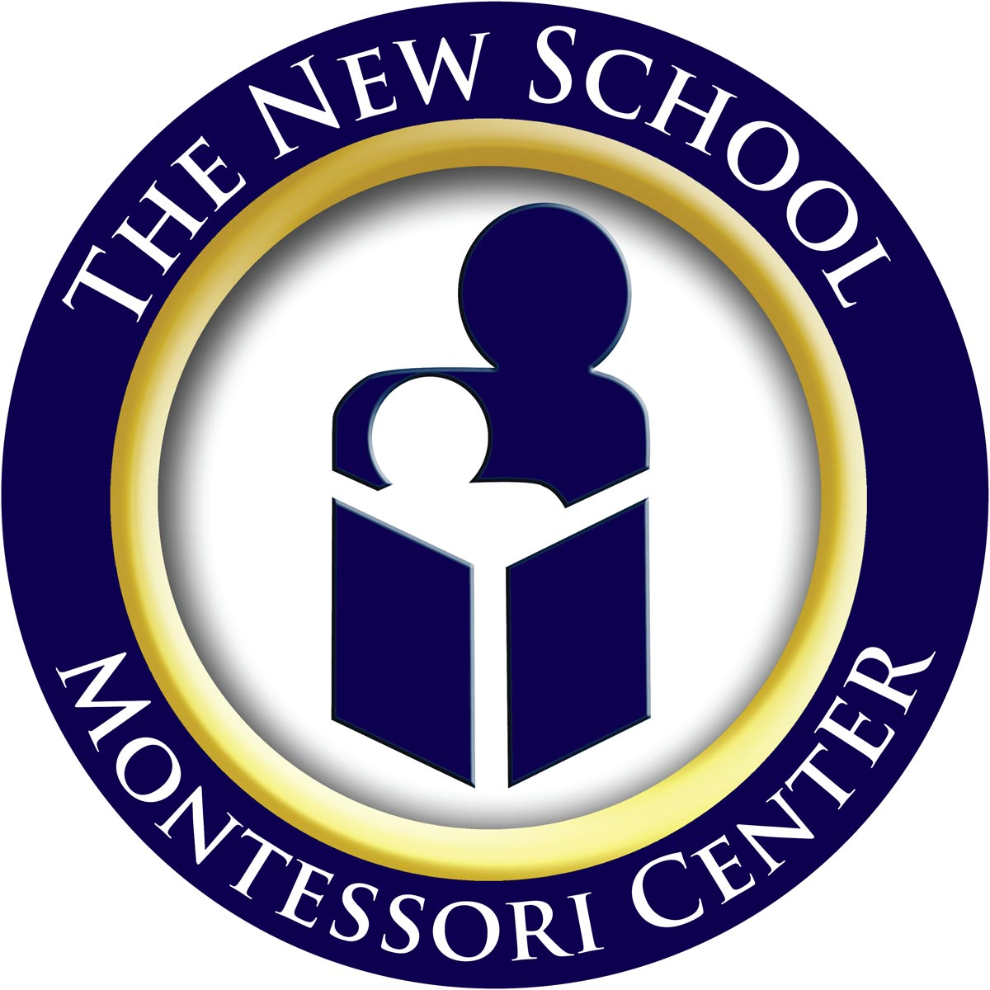

The New School, Inc.
A Montessori Center for Children

Part-Time Tuition Rates for the 2012-2013 School Year

The tuition rates listed below apply to parents wishing to enroll their children for fewer than five days.

To assist your child in achieving the maximum benefit from our program and to assist our classrooms in normalizing optimally, our split-week options are scheduled on consecutive days.
Two-Day Schedule: Mondays and Tuesdays
Three-Day Schedule: Wednesdays, Thursday, and Fridays
Four-Day Schedule: Days subject to availability

We also strongly suggest that families plan ahead when signing up for programs. If you feel you may end up increasing the number of days, you may run into space issues if you wait too long.

Infant Program
Two-Day Schedule | Three-Day Schedule | Four-Day Schedule
Half Day Program  (8:30am – 12:00pm)  $3,290.00 | Half Day Program  (8:30am – 12:00pm)  $4,935.00 | Half Day Program  (8:30am – 12:00pm)  $5,992.50
Full Day Program  (8:30am – 4:30pm)  $5,390.00 | Full Day Program  (8:30am – 4:30pm)  $8,085.00 | Full Day Program  (8:30am – 4:30pm)  $9,817.50

Toddler Ones Program
Two-Day Schedule | Three-Day Schedule | Four-Day Schedule
Half Day Program  (8:30am – 12:00pm)  $3,150.00 | Half Day Program  (8:30am – 12:00pm)  $4,725.00 | Half Day Program  (8:30am – 12:00pm)  $5,737.50
Full Day Program  (8:30am – 4:30pm)  $5,180.00 | Full Day Program  (8:30am – 4:30pm)  $7,770.00 | Full Day Program  (8:30am – 4:30pm)  $9,435.00

Toddler Twos Program
Two-Day Schedule | Three-Day Schedule | Four-Day Schedule
Half Day Program  (8:30am – 12:00pm)  $3,010.00 | Half Day Program  (8:30am – 12:00pm)  $4,515.00 | Half Day Program  (8:30am – 12:00pm)  $5,482.50
Full Day Program  (8:30am – 4:30pm)  $4,830.00 | Full Day Program  (8:30am – 4:30pm)  $7,245.00 | Full Day Program  (8:30am – 4:30pm)  $8,797.50

Children’s House Program
Two-Day Schedule | Three-Day Schedule | Four-Day Schedule
Half Day Program  (8:30am – 12:00pm)  $2,632.00 | Half Day Program  (8:30am – 12:00pm)  $3,948.00 | Half Day Program  (8:30am – 12:00pm)  $4,794.00
Extended Day Program  (8:30am – 3:00pm)  $3,640.00 | Extended Day Program  (8:30am – 3:00pm)  $5,460.00 | Extended Day Program  (8:30am – 3:00pm)  $6,630.00
Elementary Sibling Program  (8:30am – 3:30pm)  $3,850.00 | Elementary Sibling Program  (8:30am – 3:30pm)  $5,775.00 | Elementary Sibling Program  (8:30am – 3:30pm)  $7,012.50
Full Day Program  (8:30am – 4:30pm)  $4,270.00 | Full Day Program  (8:30am – 4:30pm)  $6,405.00 | Full Day Program  (8:30am – 4:30pm)  $7,777.50

Please note that if your child is of Kindergarten age, you must first request administrative approval before enrolling your child in fewer than 4 days. We also strongly advise all Kindergarten children being enrolled in an Extended Day program in order to enhance and reinforce the academic skills they are learning in the class.

Please visit the Programs page on our website at www.montessoricenter.org for details on any of the programs mentioned above.

5617 Sunset Lake Road, Holly Springs, NC 27540
Tel: 919-303-3636 • Fax: 919-303-3605 • www.montessoricenter.org • info@montessoricenter.org

